**Vision Document for “Online-Shopping”**

**Team members:**

*[Muluken Deneke - 110198]*

**1. Introduction**

There are dozens of online shopping websites that sell jerseys. Customers struggle to find a single website to order different jerseys for different sports and teams. Thus, they must search multiple websites whenever they are looking to order multiple jerseys for groups of people like family and/or friend members.

In collaborations with different leagues and jersey brands: our online shopping will have four of most of the popular sports (Baseball, Basketball, Soccer, and Football) jerseys available for sell from diversified nationalities, different leagues, and teams. Now that users can find most jerseys on a single website, they are able to cut down shipping costs, their time and energy as well as avoid scam websites.

**2. Positioning**

**2.1 Problem Statement**

*[Provide a statement summarizing the problem being solved by this project. The following format may be*

*used:]*

|  |  |
| --- | --- |
| The problem of | *Shopping multiple sports and/or teams jerseys from different websites is time and money costly.* |
| Affects | *Jersey shoppers, brands and Sport teams* |
| the impact of which is | *Shopping multiple jerseys is difficult and must be improved and simplified for users.* |
| a successful solution would be | *On a single website users (online shoppers) are able to find various teams jerseys from diversified sports as well as clubs and leagues.* |

**2.2 Product Position Statement**

*[Provide an overall statement summarizing, at the highest level, the unique position the product intends to*

*fill in the marketplace. The following format may be used:]*

|  |  |
| --- | --- |
| For | *[target customer]* |
| Who | *[statement of the need or opportunity]* |
| The (product name) | *is a [product category]* |
| That | *[statement of key benefit; that is, the compelling reason to buy]* |
| Unlike | *[primary competitive alternative]* |
| Our product | *[statement of primary differentiation]* |

*[A product position statement communicates the intent of the application and the importance of the project*

*to all concerned personnel.]*

**3. Stakeholder Descriptions**

**3.1 Stakeholder Summary**

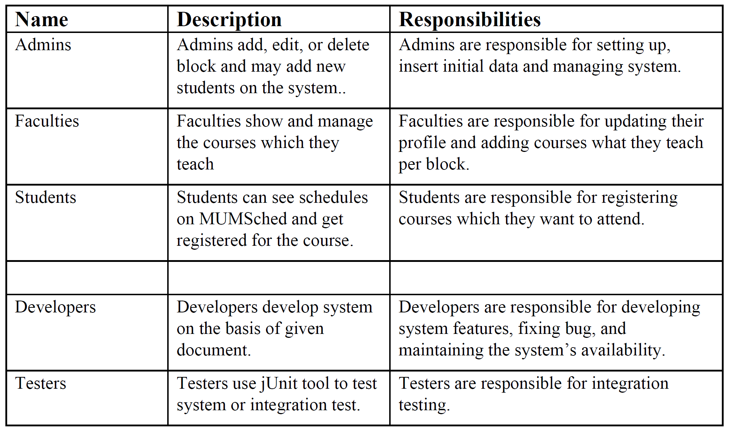

**3.2 User Environment**

*[Detail the working environment of the target user. Here are some suggestions:*

*Number of people involved in completing the task? Is this changing?*

*How long is a task cycle? Amount of time spent in each activity? Is this changing?*

*Any unique environmental constraints: mobile, outdoors, in-flight, and so on?*

*Which system platforms are in use today? Future platforms?*

*What other applications are in use? Does your application need to integrate with them?*

*This is where extracts from the Business Model could be included to outline the task and roles involved,*

*and so on.]*

**4. Product Overview**

**4.1 Product Perspective**

*[This subsection of the* ***Vision*** *document puts the product in perspective to other related products and the*

*user’s environment. If the product is independent and totally self-contained, state it here. If the product is a*

*component of a larger system, then this subsection needs to relate how these systems interact and needs to*

*identify the relevant interfaces between the systems. One easy way to display the major components of the*

*larger system, interconnections, and external interfaces is with a block diagram.]*

**4.2 Assumptions and Dependencies**

*[List each factor that affects the features stated in the* ***Vision*** *document. List assumptions that, if changed,*

*will alter the* ***Vision*** *document. For example, an assumption may state that a specific operating system will*

*be available for the hardware designated for the software product. If the operating system is not available,*

*the* ***Vision*** *document will need to change.]*

**4.3 Needs and Features**

*[Avoid design. Keep feature descriptions at a general level. Focus on capabilities needed and why (not*

*how) they should be implemented.]*

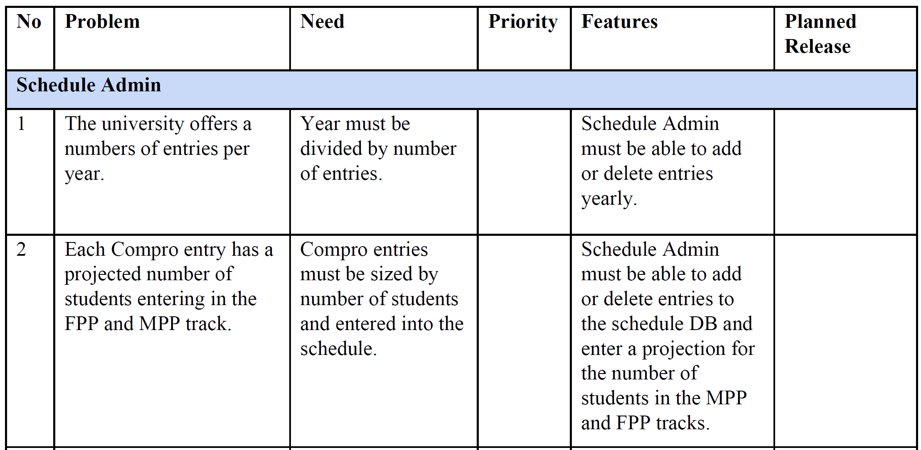

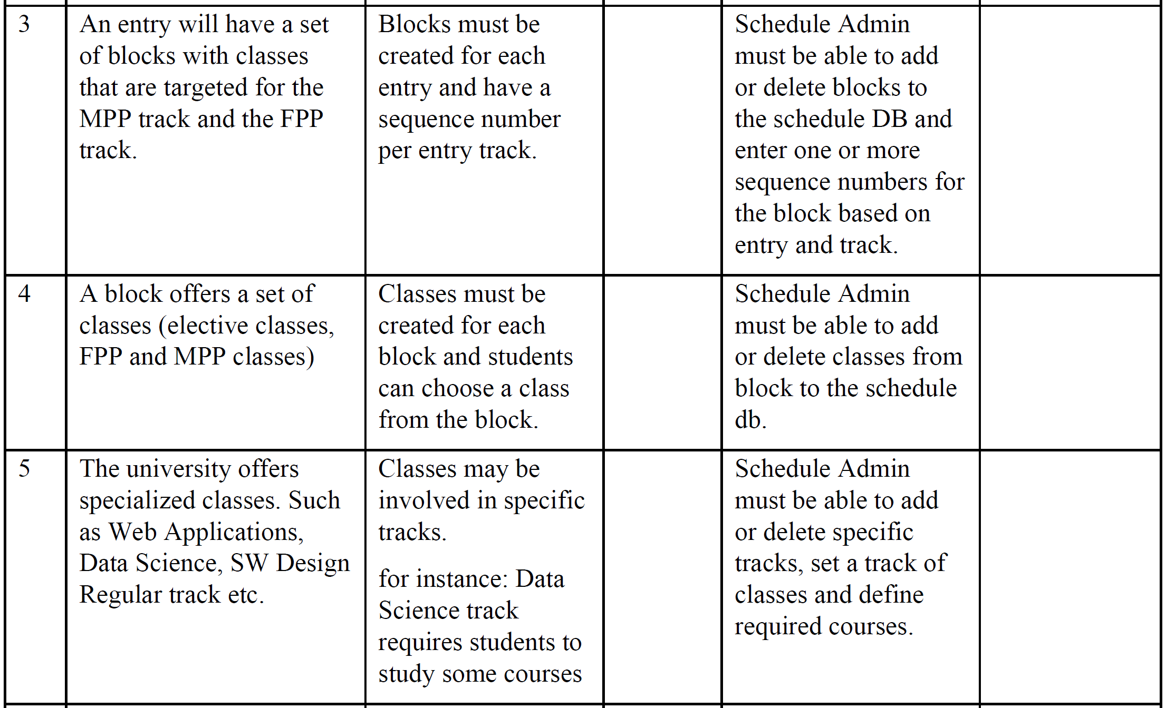

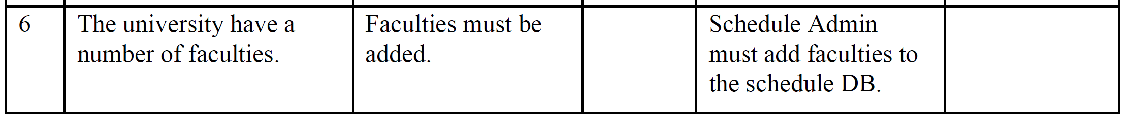

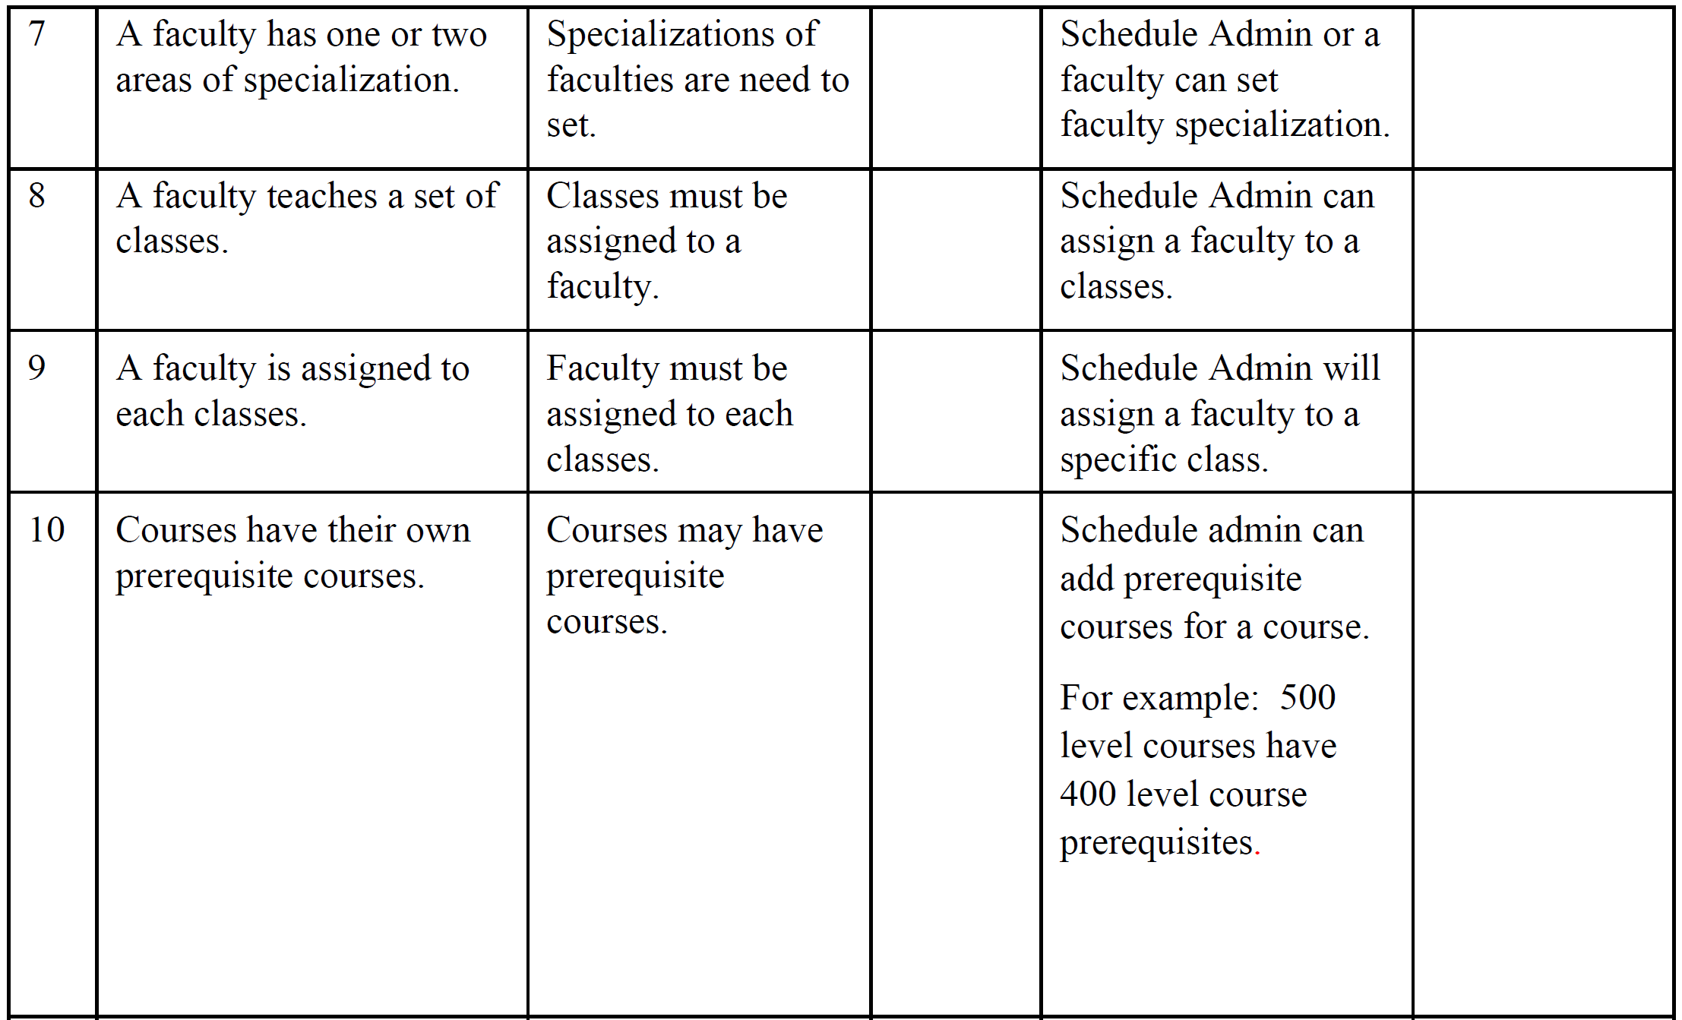

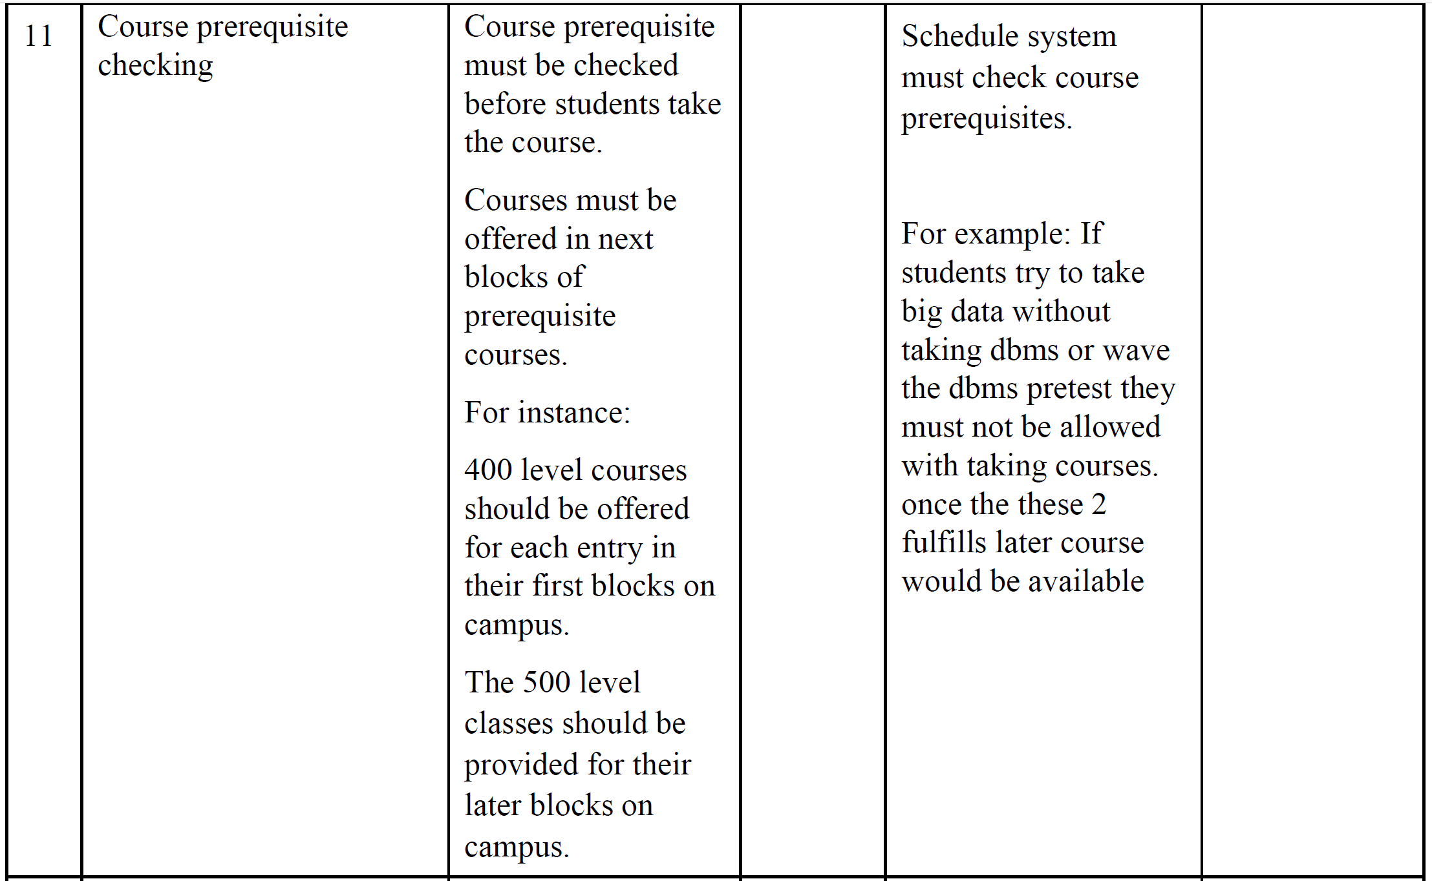

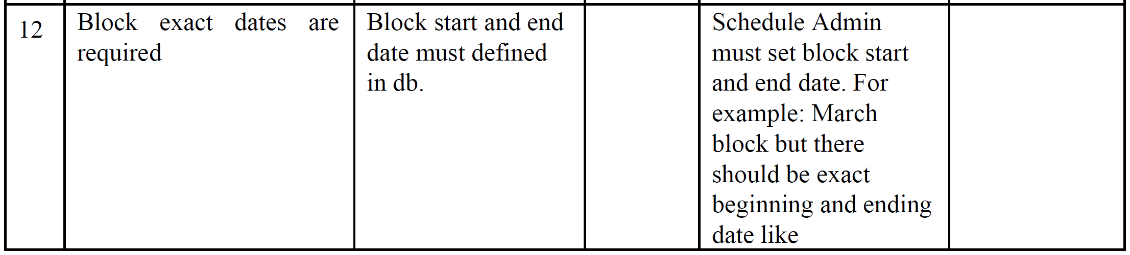

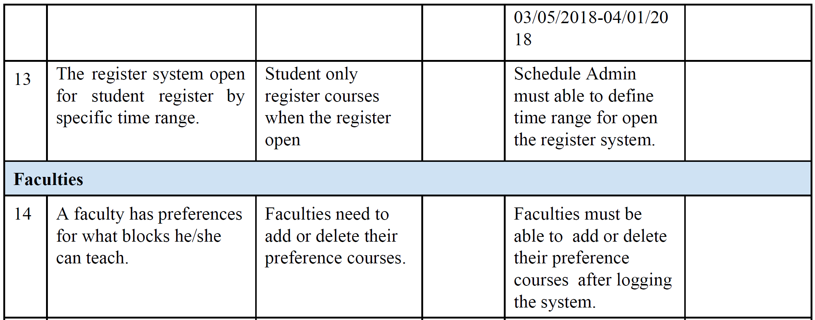

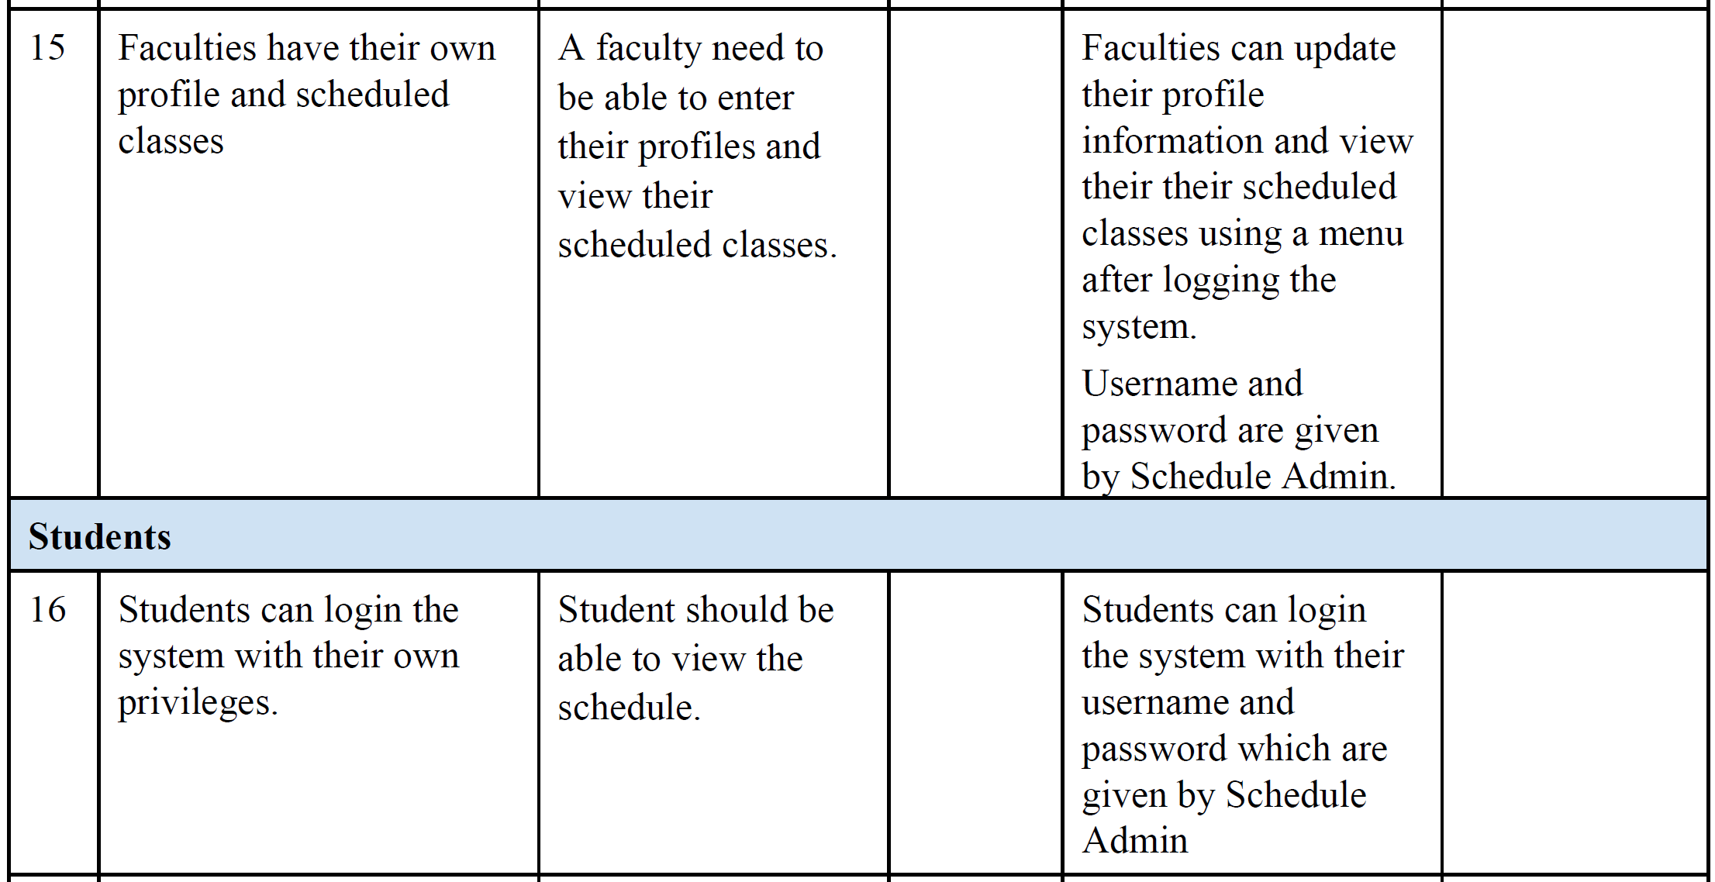

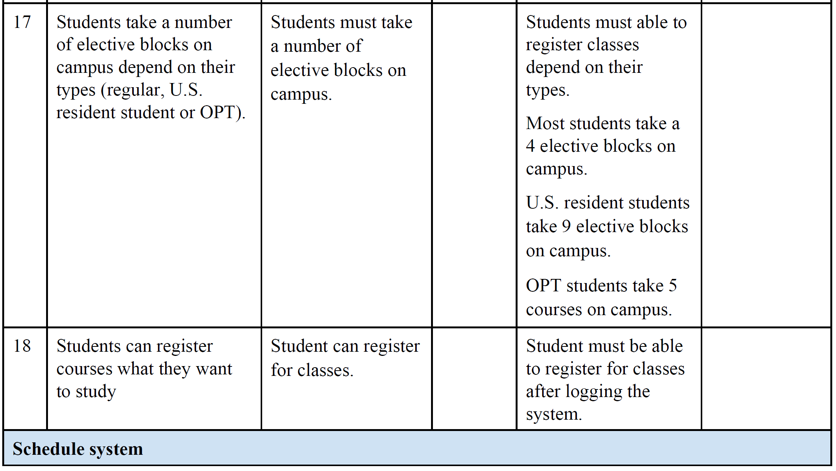

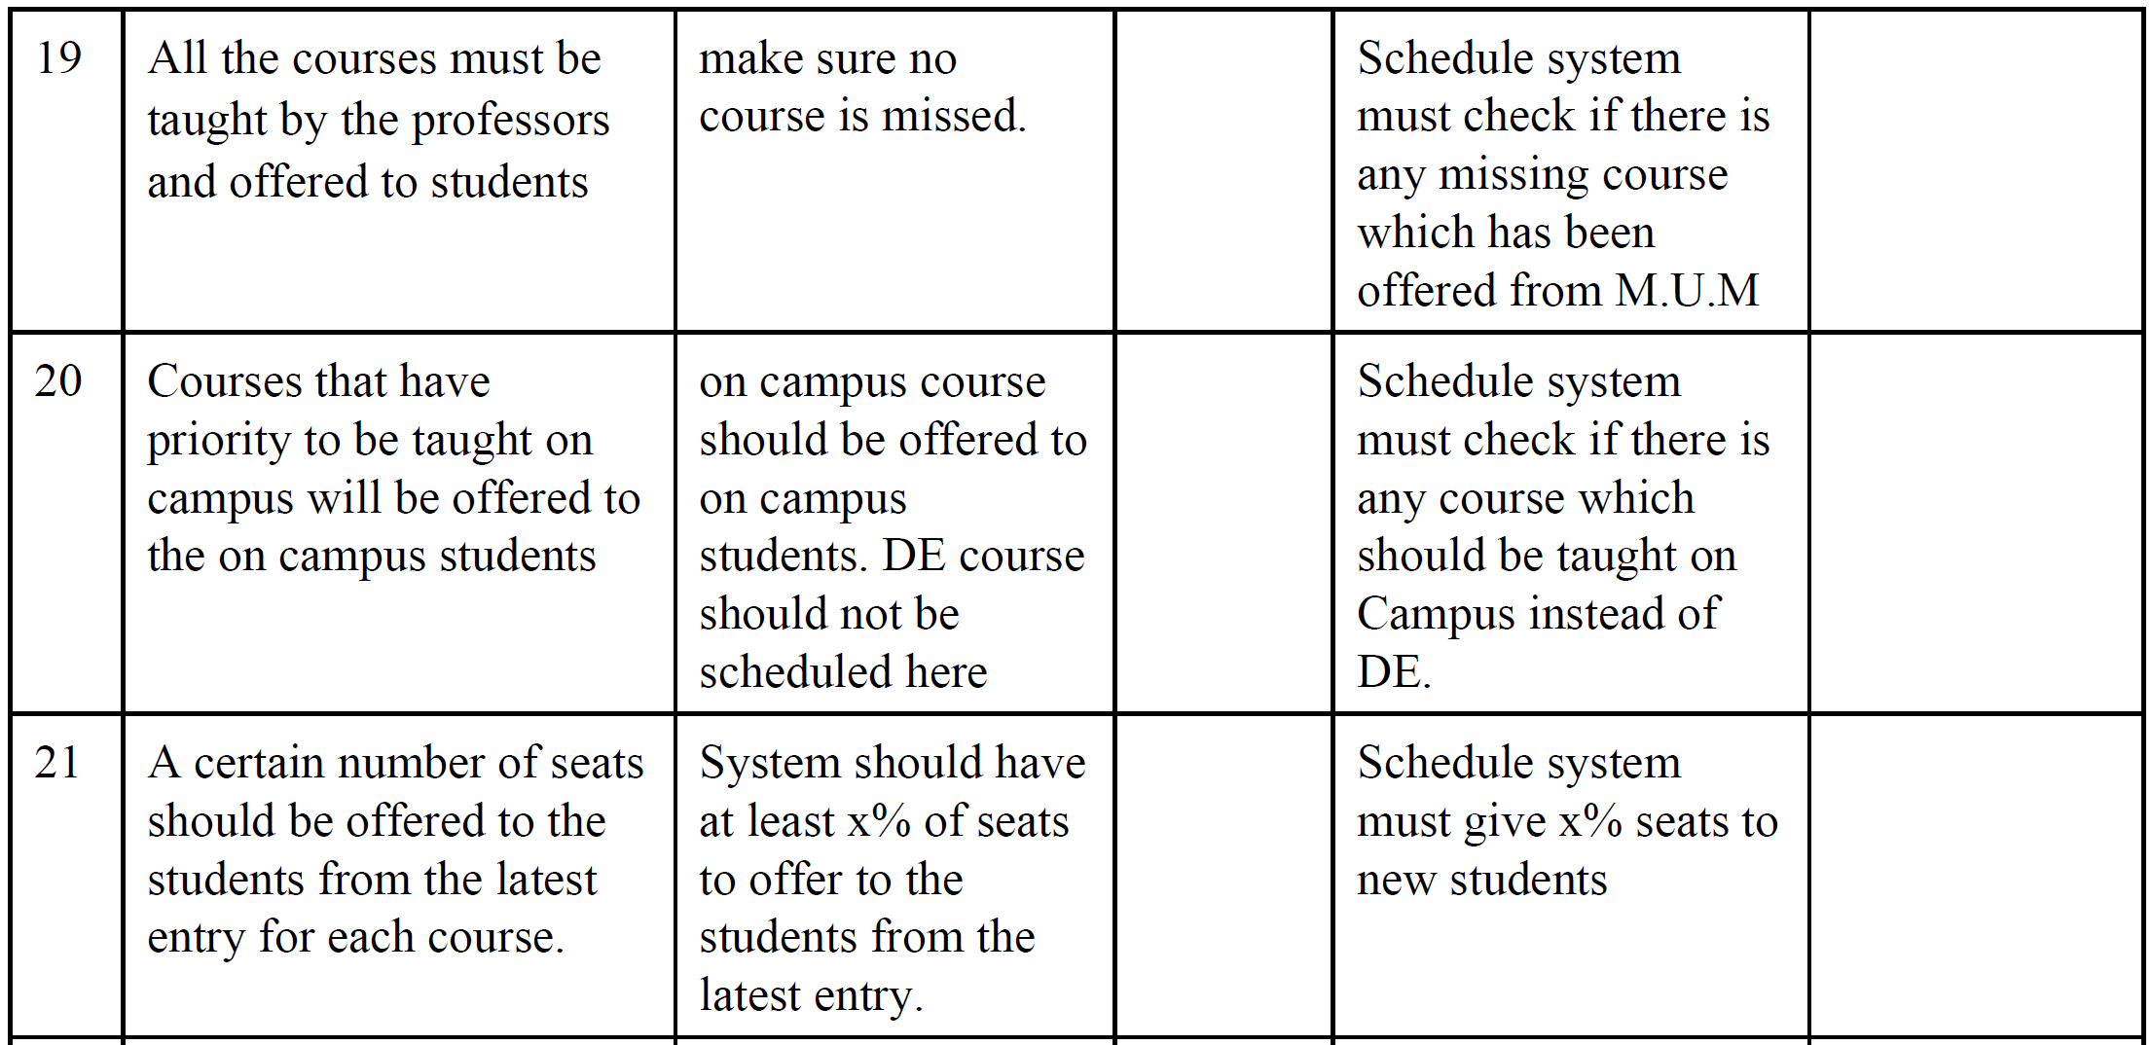

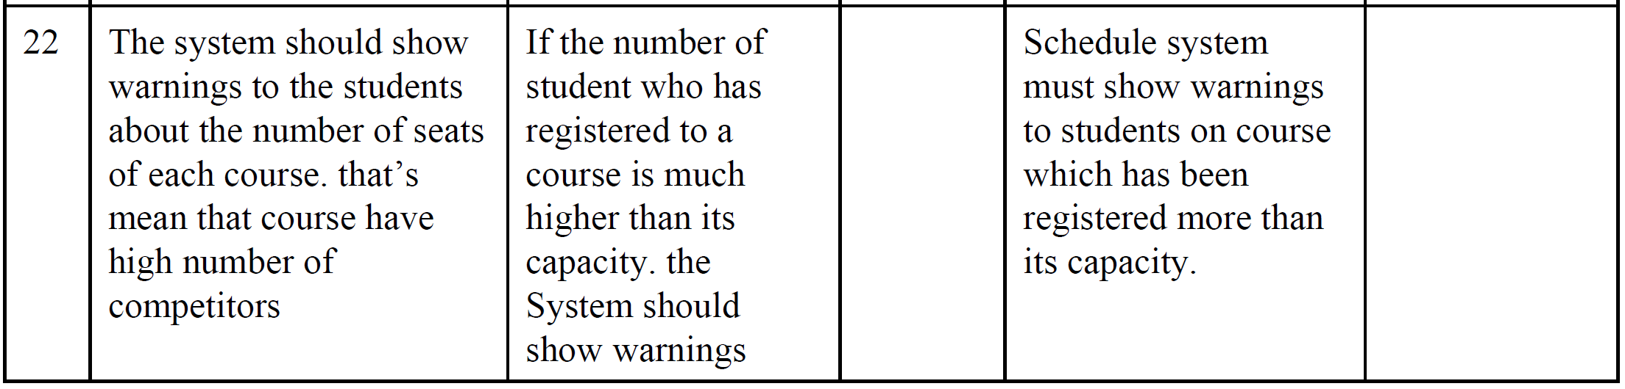

**4.4 Alternatives and Competition**

*[Identify alternatives the stakeholder perceives as available. These can include buying a competitor’s*

*product, building a homegrown solution, or simply maintaining the status quo. List any known competitive*

*choices that exist or may become available. Include the major strengths and weaknesses of each competitor*

*as perceived by the stakeholder or end user.]*

**5. Other Product Requirements**

*[At a high level, list applicable standards, hardware, or platform requirements; performance requirements;*

*and environmental requirements.*

*Define the quality ranges for performance, robustness, fault tolerance, usability, and similar*

*characteristics that are not captured in the Feature Set.*

*Note any design constraints, external constraints, or other dependencies.*

*Define any specific documentation requirements, including user manuals, online help, installation,*

*labeling, and packaging requirements.*

*Define the priority of these other product requirements. Include, if useful, attributes such as stability,*

*benefit, effort, and risk.]*